Xiangnan Xiong

University of Texas at Austin

**Meyer, Hannes (1889-1954)**

Hannes Meyer was a Swiss modernist architect, educator, and the second director of the BAUHAUS from 1928 to 1930. He believed that architecture and planning are social issues and that modern architects and planners should serve the needs of the masses rather than those of the privileged class. This conviction directed him throughout his entire career.

Meyer was born on November 18, 1889, into an architectural dynasty in Basel. He was an apprentice mason and studied building at Basel Technical School for four years before going to Berlin in 1909, where he attended courses on town planning, economics and land reform. Between 1912 and 1913, Meyer traveled to England, visiting and studying the garden cities of Letchworth, Bourneville and Port Sunlight. By the time World War I broke out, Meyer had already completed his training in architecture and town planning. During the war, he served in the Swiss army.

In 1919, Meyer received his first building commission: Freidorf housing estate near Basel, in which he used standardized building elements for the sake of economic efficiency. Meyer was appointed as master of architecture at the Bauhaus in 1927. A year later, he succeeded WALTER GROPIUS as the director of the Dessau Bauhaus. He conducted an extensive reform of the Bauhaus curriculum, stressing practical experience and downplaying personal artistic concerns. He grouped workshops into four sections (building, advertising, interiors and textiles) and added a series of courses introducing modern scientific and technical theories that were relevant to design. In so doing, he grounded architecture in its material and economic conditions, while suppressing subjective expression in making architecture. Under Meyer’s direction, the Bauhaus workshops collaborated with industrial production more effectively, which greatly alleviated its pressing financial problems. In 1928, Meyer took an active role in founding the International Congresses for Modern Architecture (CIAM). From 1928 to 1930, he designed and supervised the construction of the Federal School of the General German Trade Unions Federation at Bernau. The layout of the plan showed careful consideration of the programme and offered a sensible response to the contour of the site and the local climate. In July 1930, Meyer was dismissed from the Bauhaus for allegedly spreading Communist ideas.

In the autumn of 1930, Meyer moved to the Soviet Union with a few former Bauhaus students. He served as a consultant at the Soviet Institute for Urban and Investment Development (Giprovtus) and worked out development plans for a series of towns for the first five-year plan. Due to the serious lack of building materials and increasingly hostile climate towards modernism in the Soviet Union, Meyer found few opportunities to build there.

In 1936 Meyer returned to Switzerland for three years and then travelled to Mexico. He accepted the invitation to become director of the newly formed institute for Town and National Planning of Mexico, which was closed for lack of funds in 1941. From 1944 to 1949, Meyer was appointed architect-secretary of the planning commission for hospitals and clinics in Mexico, and he worked out town planning schemes for various spa centers. Meyer returned to Switzerland in 1949, and died in 1954.

**List of major works**

1919-21 Freidorf housing estate, Muttenz, Swizerland.

1926-27 Project for the Palace of the League of Nations, Geneva, Swizerland.

1928-30 Törten housing estate, Dessau, Germany.

1928-30 Federal School of the GGTUF, Bernau, Germany.

1931-32 Plan for the development and reconstruction of Moscow, Soviet Union.

1946-47 Development Plan for the Agua Hedionda Spa Center, Cuautla, Mexico.

**References and further reading**

Meyer, Hannes & Claude Schnaidt. (1965) *Hannes Meyer: Bauten, Projekte und Schriften; Buildings, projects and writings*, Trans. D. Q. Stephenson, New York: Architectural Book Publishing Co.

Kieren, Martin. (1990) *Hannes Meyer: Dokumente zur Frühzeit, Architektur und Gestaltungsversuche 1919-1927*, Heiden: A. Niggli.

Hays, K. Michael. (1995) *Modernism and the Posthumanist Subject: the Architecture of Hannes Meyer and Ludwig Hilberseimer*, Cambridge, Mass.: MIT Press.

Visual materials:

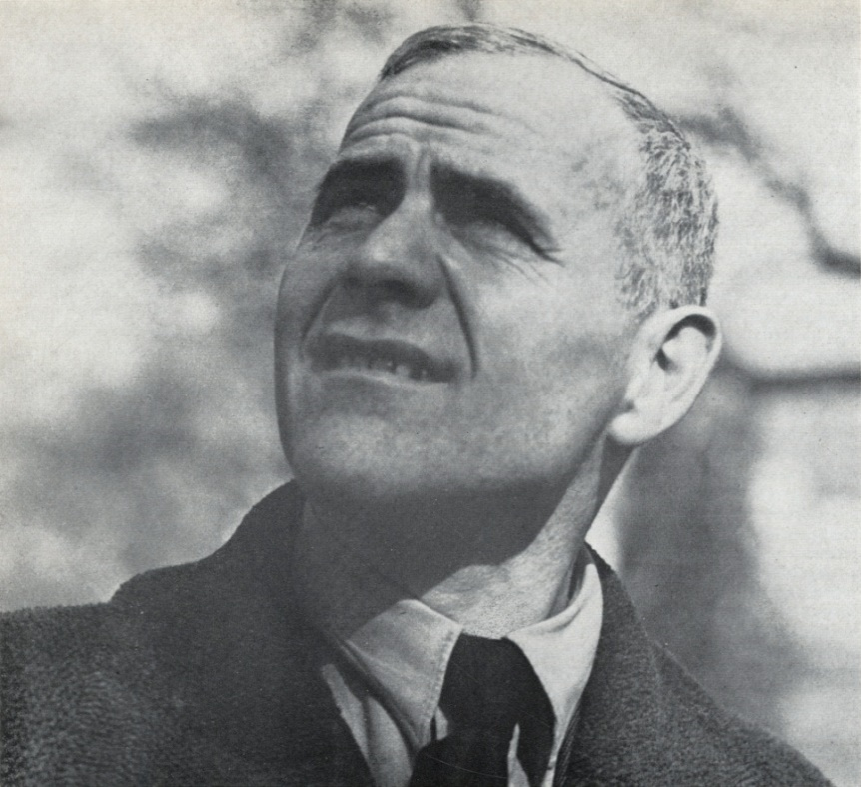

Hannes Meyer in 1930 shortly after he arrived at Soviet Union

Copyright: The Charnel-House <http://thecharnelhouse.org/2013/08/10/hannes-meyer/>

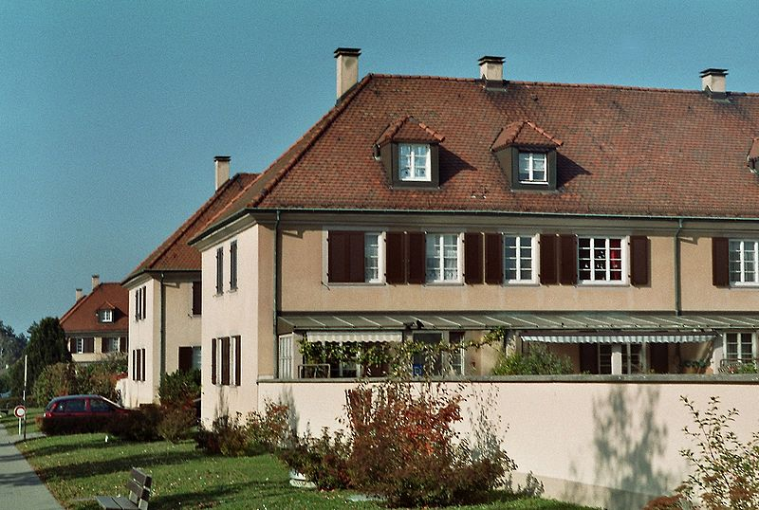

Freidorf housing estate, Muttenz, photographed in 2005.

Copyright: Wikipedia <http://en.wikipedia.org/wiki/File:Meyer_muttenz.jpg>

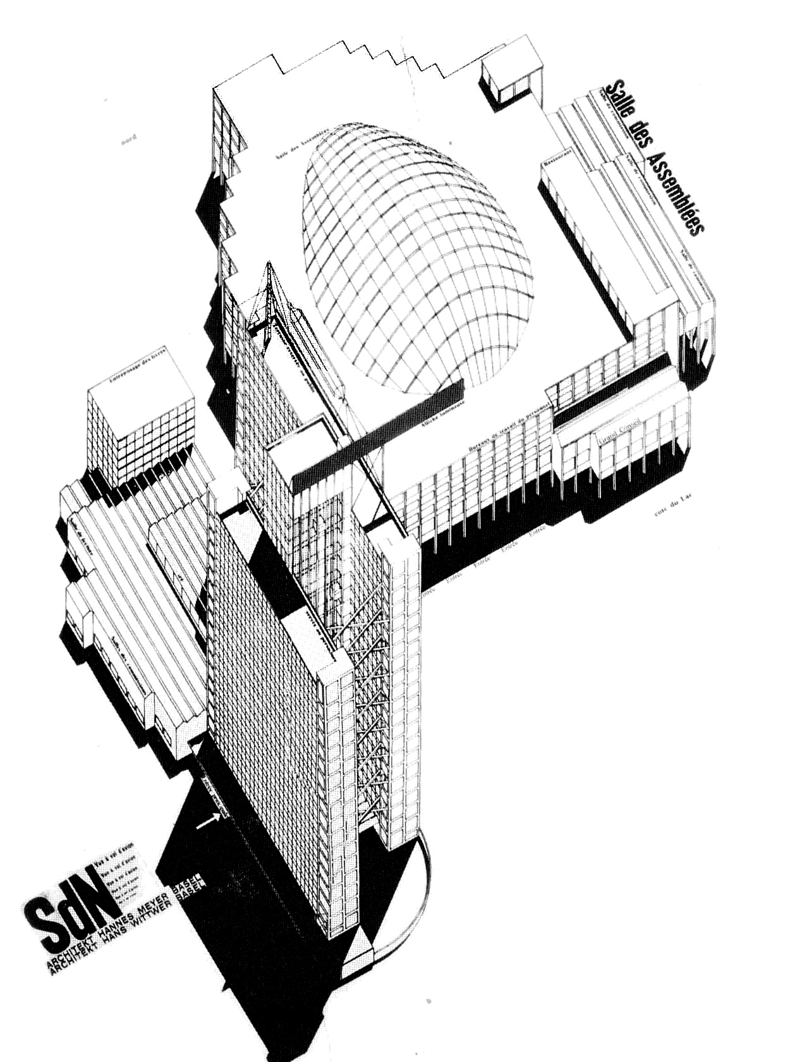

Project for the Palace of the League of Nations, Geneva, 1926-27.

Copyright: The Charnel-House <http://thecharnelhouse.org/2013/08/10/hannes-meyer/>

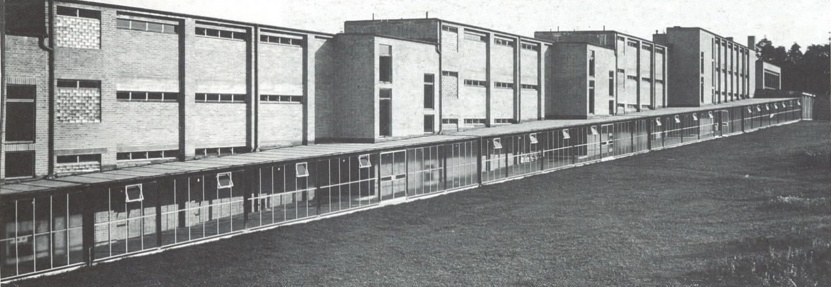

Federal School of the GGTUF, Bernau, Germany, 1928-30.

Copyright: TU Delft <http://thecityasaproject.org/2013/05/hannes-meyer-co-op-architecture/>

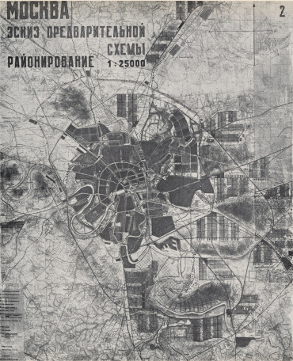 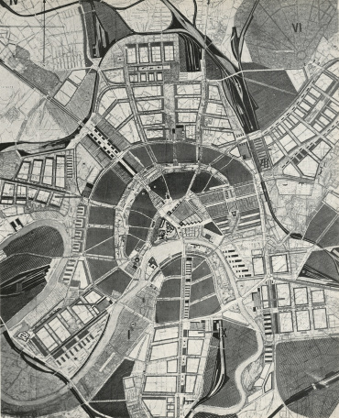

Plan for the reconstruction of Moscow, Soviet Union, 1931-32.

Copyright: The Charnel-House <http://thecharnelhouse.org/2013/08/10/hannes-meyer/>